Solaris PAM module

Project
There are three modules that contain the same C code:
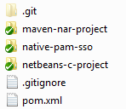

maven-nar-project
The NAR project is based on the maven nar plugin and allows to build C code platform independently. This is the most flexible and future proof way of compiling the PAM module if you were to re-use the code for Linux for example, that wouldn’t be a problem.
The plugin is not in any well-known public repository, so you need to build it yourself or add a custom public repository. The ImageJ repository does host this plugin.

native-pam-sso
This project is based on the native-maven-plugin. This plugin has less options than the maven-nar-plugin. It doesn’t provide JNI, which allows you to write Java JUnits tests for your native code. It also doesn’t handle build environment specific variables, such as guessing the C compiler and C linker based on OS-information. However, due to the easier setup and availability in well-known public repositories, this is the plugin to be used.

netbeans-c-project
This project is based on the C/C++ plugin for Netbeans 7.2.1 and is configured to build on a remote host, which is a 13A Solaris 10 x86 machine located at 10.59.131.248. This is the project most suitable for development purposes. It contains working CUnit tests and packages a working .so file on the remote machine. During testing you would typically build from you IDE and use a Putty session to copy the resulting .so file to the right location to activate it. Then you can start logging in to the Solaris machine or start a Citrix Session to do manual integration testing.
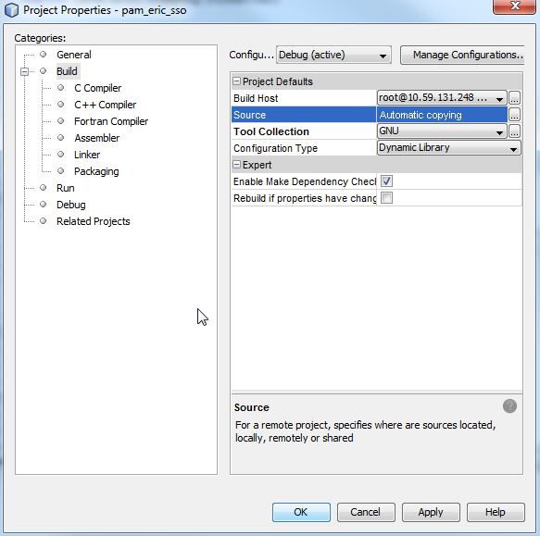

Deployment
Once the source code is built, the package is called
libpam_eric_sso.so
but can be renamed to any name required. Place this file on the Solaris machine with the other Pam modules.
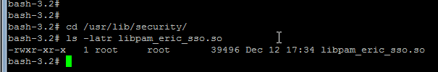
To activate the PAM module, modify the following file
/etc/pam.conf
Below is a screenshot of this file with this PAM module enabled.
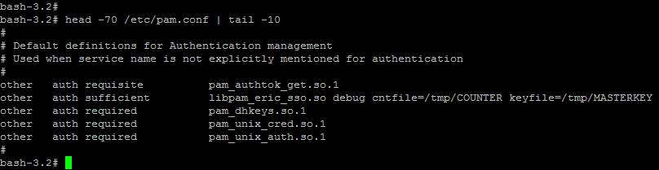
The second line of this PAM chain is the configuration required for activating our module.
other | indicates for which service this chain is active. This should be changed to “ica” in a production environment to make it specific for Citrix
auth | This module does authentication only
sufficient | If it failes, fall back to the other modules for backwards compatibility. If it succeeds, don’t proceed to other modules
libpam_eric_sso.so | This is the module. Assumed to be in /usr/lib/security
debug | Specific for our module: enable debug logging
cntfile=… | Specific for our module: indicate the counter file location
keyfile=… | Specific for our module: indicate the master key file location

See also. The reason we place our module on the second line is because we don’t want to implement fetching the password ourselves. The pam_authtok_get.so.1 module handles that for us by default

Debugging
To enable debugging on a the deployed PAM module, these are the steps to take
- add the debug keyword to the pam configuration in /etc/pam.conf file
- execute touch /etc/pam_debug
- Add the following line to /etc/syslog.conf (make sure they’re tabs, not spaces)
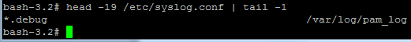
- execute touch /var/log/pam_log
- restart the syslog: svcadm restart svc:/system/system-log:default
- follow the log: tail –f /var/log/pam_log

Manual Integration Testing
When modifying PAM modules, always keep a session as root open on the machine, so in case you configuration is broken, you are not locked out of the server.
When executing a build from Netbeans on the netbeans-c-project, the files are copied to the Solaris machine and the build commands are executed remotely through SSH. The files on the remote machine are in
/.netbeans/remote
On that location there are many subdirectories based on the Netbeans workstation. For example the .so would be here:
/.netbeans/remote/10.59.131.248/e7b499baedc65d-Windows-x86_64/H/git/SingleSignOnPam/netbeans-c-project/dist/Debug/GNU-Solaris-x86/libnetbeans-c-project.so
After the configuring the keyfile, counterfile, pam.conf and debugging you can start testing. Simply create script to copy the .so file to /usr/lib/security and call that script after each build.
Then attempt a login with an SSH client such as Putty or try a direct connection with the Citrix client.

Source
Repository URL is:
ssh://cifwk-oss.lmera.ericsson.se:29418/com.ericsson.nms.sso/SingleSignOnPam
There are eight source files (*.c). Seven of them have a corresponding header file (*.h)
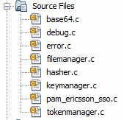

pam_ericsson_sso

keymanager

tokenmanager

pam_ericsson_sso
Implements the PAM modules API for an authentication module. Parses the configuration parameters set in /etc/pam.conf. It also handles getting the username/password from the user, calling the tokenmanager to parse the token, calling the keymanager to validate the presented token and counter and calling the filemanager to update the counter.

keymanager
Implements methods for generating HMAC-tokens and validating them against presented tokens.
Parses a presented token in the form “1234-base64encodedstring” to a separate number and base64 encoded string in safe way.

filemanager
Read and write from files for interaction with the counter file and the master key file.

hasher
Provide functions for creating a keyed_hash and regular hash.

base64
Provide functions for encoding in base64 and base12 (hex encoded string).

debug
Enables and handles logging.

error
Provides a buffer for holding error messages.

http://duns.github.com/maven-nar-plugin/
https://issues.sonatype.org/browse/NAR
http://dev.loci.wisc.edu:8081/content/groups/public
http://mojo.codehaus.org/maven-native/native-maven-plugin/
http://stackoverflow.com/questions/6622625/maven-nar-plugin-vs-native-maven-plugin-which-is-better
http://netbeans.org/features/cpp/
http://docs.oracle.com/cd/E19253-01/816-4557/pam-32/index.html
http://uw714doc.sco.com/en/SEC_pam/pam_modules.html

